**M3 - Analyse actual test results against expected results to identify discrepancies**

**Introduction**

In this report, I will be analysing the test results that I have got. If they are any differences, I will explain how to fix it. I will provide screenshot to prove this.

**Ending the code**

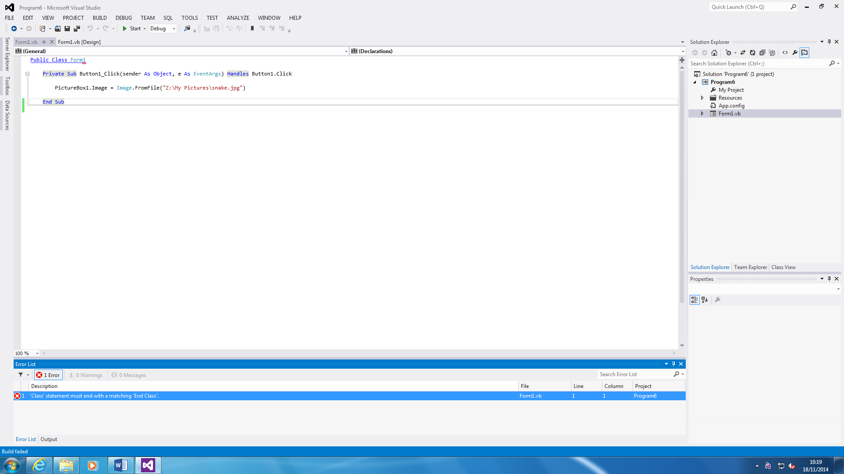



This is the debugging tool. Any errors that you have within the program, it will appear within the ‘Error List’. First of all, the error that says is the statement must end in ‘End Class’. If this is not inserted, the program cannot be started. If any errors that confuses you i.e. you do not understand what to do, you double click on it and it automatically directs to what the error is. For this, all I did is add ‘End Class’ and there was no more errors within the system. By ‘Ending Class’ to this program, it will end the code. This error is very basic. But, as an example, it works fine.

**Validation**

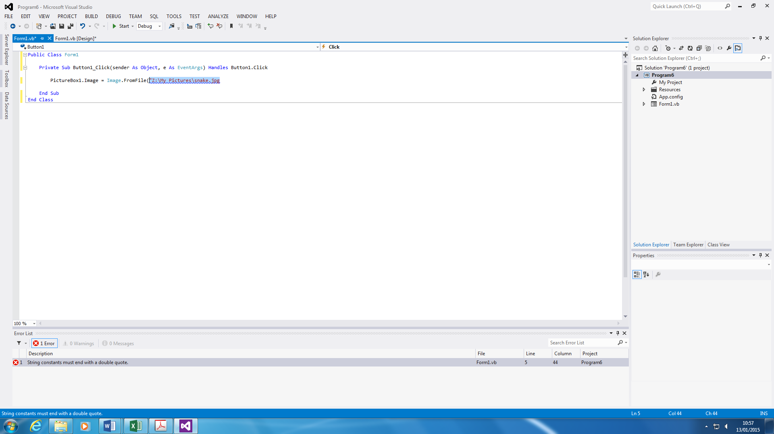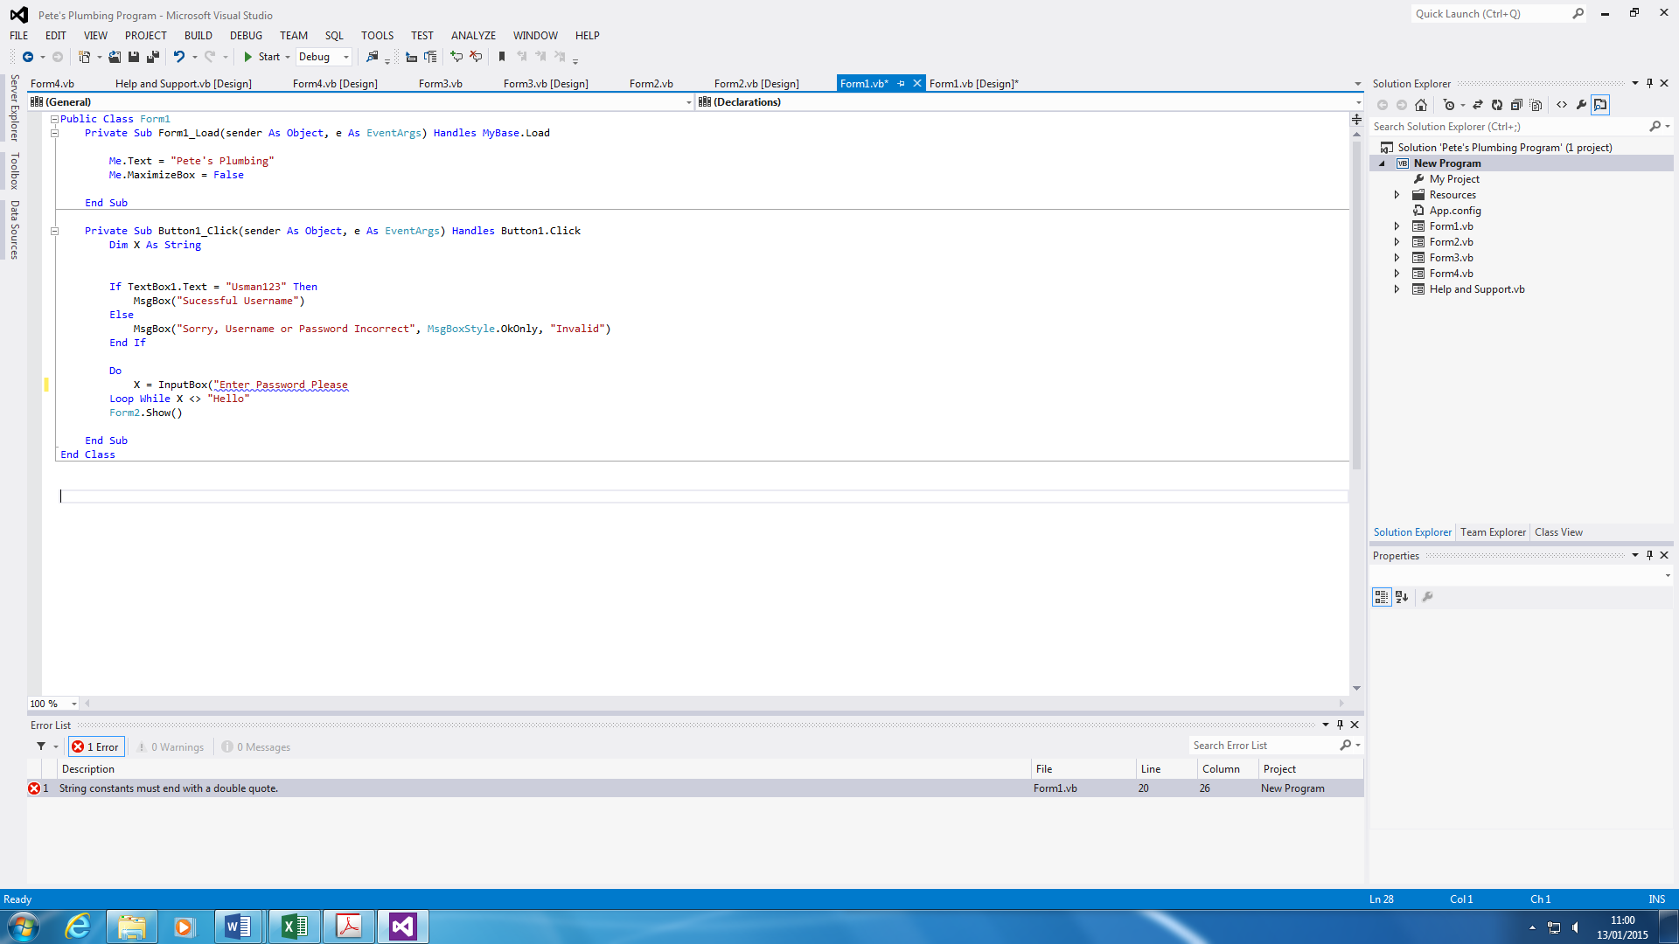

My second error in the program was to validate the program. The screenshot shows that I need to end the message with a double quote. For example, I have to end it like this, (“Enter Password Please”). If this is not ended, the program will read it as an error and it is not finished. As any other error, if this is not complete, the user cannot start the program without completing this error. The error was made, and I had to correct it by typing the rest of the quotes in, and with a closed bracket.

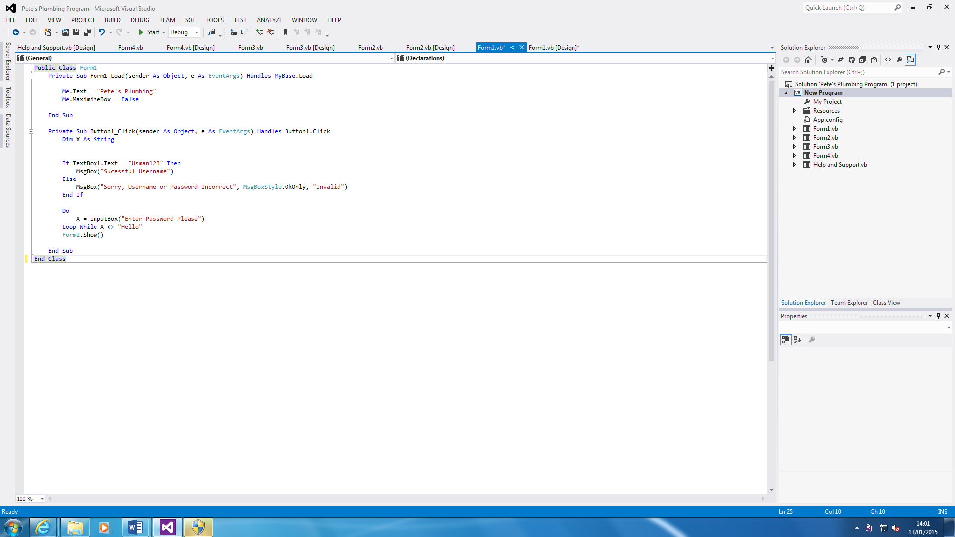**Login Screen**

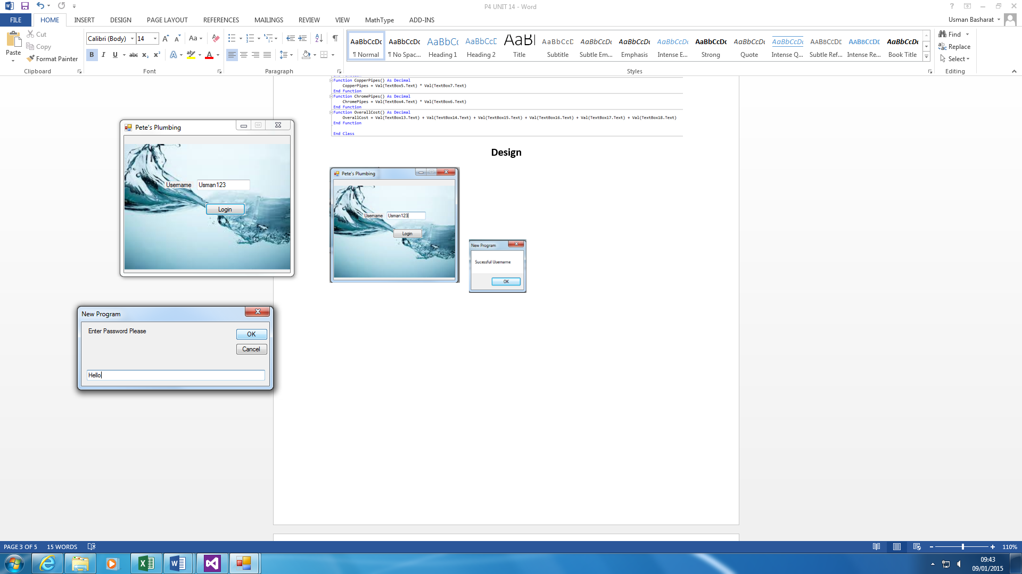

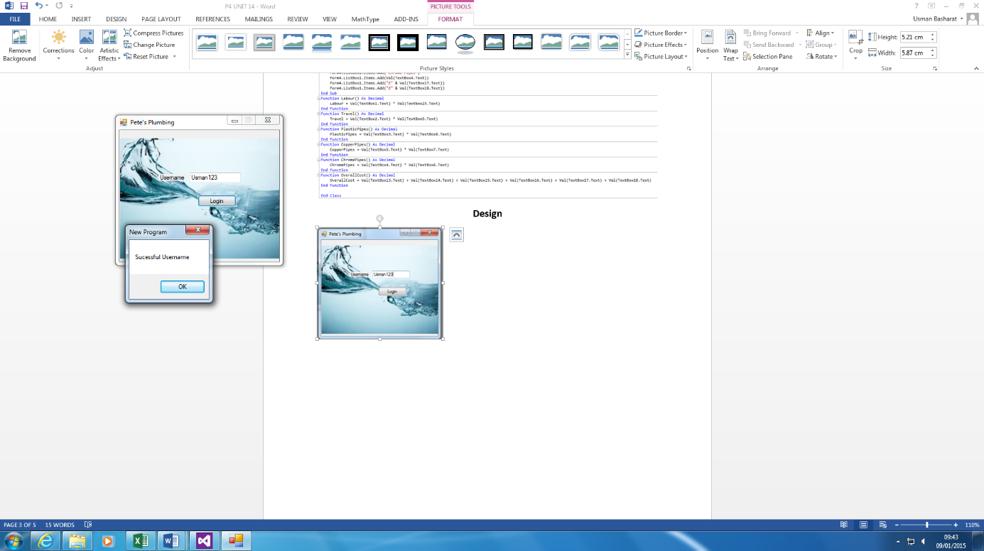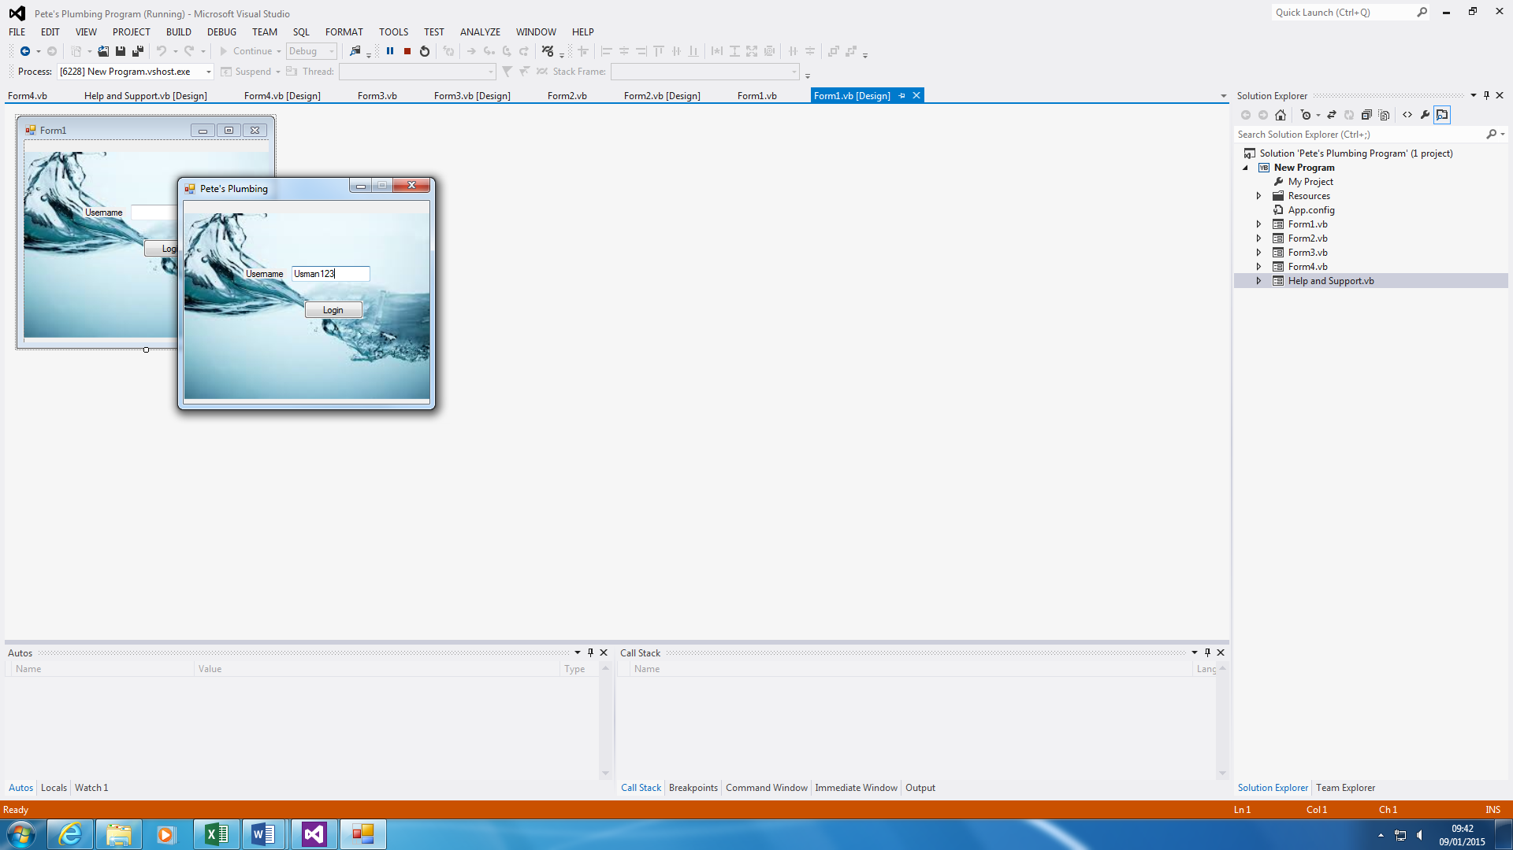

I am analysing this because I changed it to a loop when I started it. I had to figure out some way of changing it to a loop. This took very long to do and I came across some mistakes within it. Some of them was that, as you can see, before it was both logged in, but I changed it to a loop. This becomes separate.

One time, I put it in and it didn’t show the Form2. Another time, I had to fiddle about with it for it to work.

This is the login screen. As you can see, the username is typed in, and that needs to be correct in order to move on to the password. This is because the loop is over there. As you can see the code below, it shows how it works. The user will enter the username, “Usman123”, and password has to be correct in order show Form2.

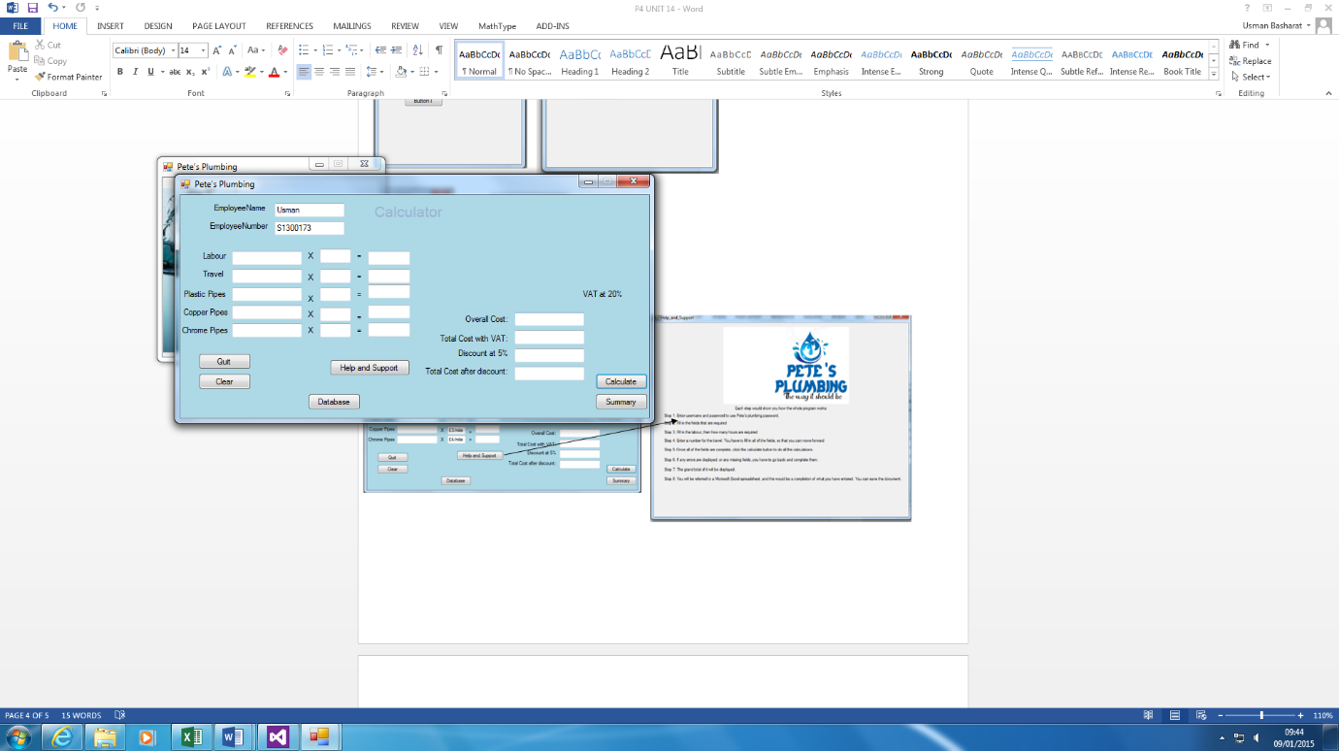

**Print**

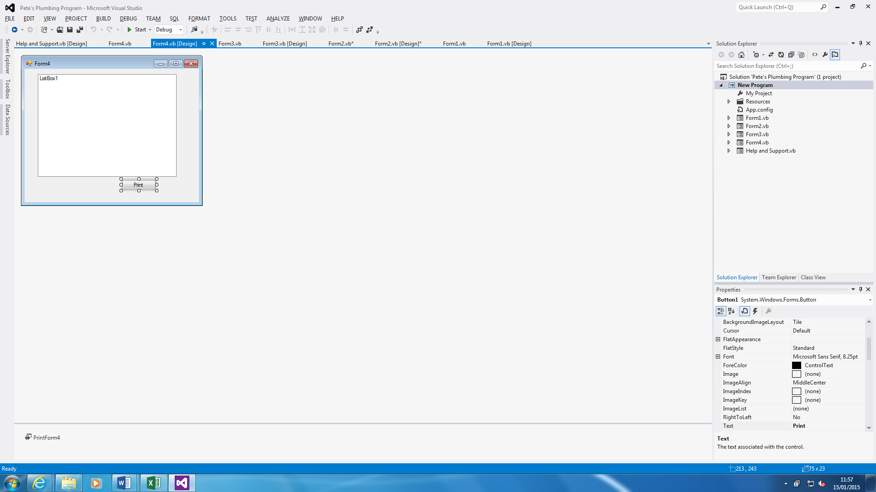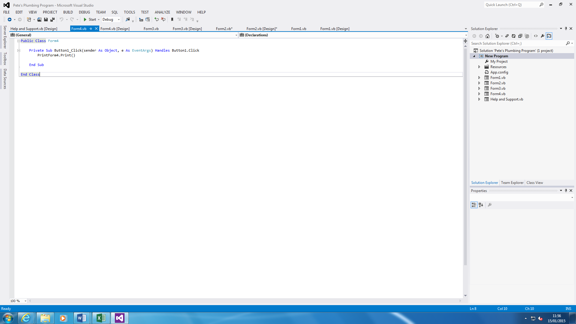

The problem that I faced during the testing was that it couldn’t recognise the code once I typed it in. It didn’t work because I had not put in the command for it to be actually do the printing. Once this was put in, it worked.

**VAT**

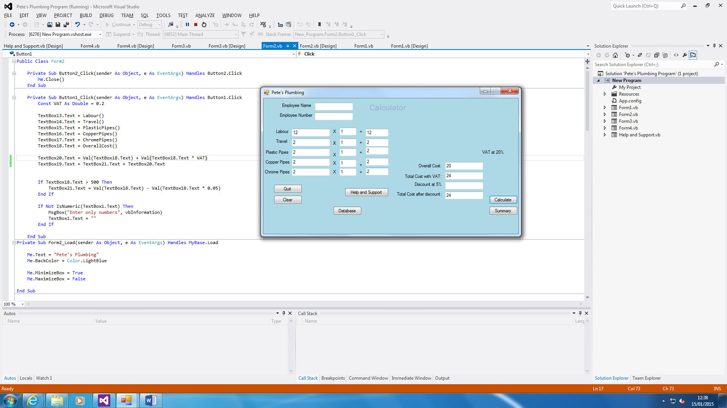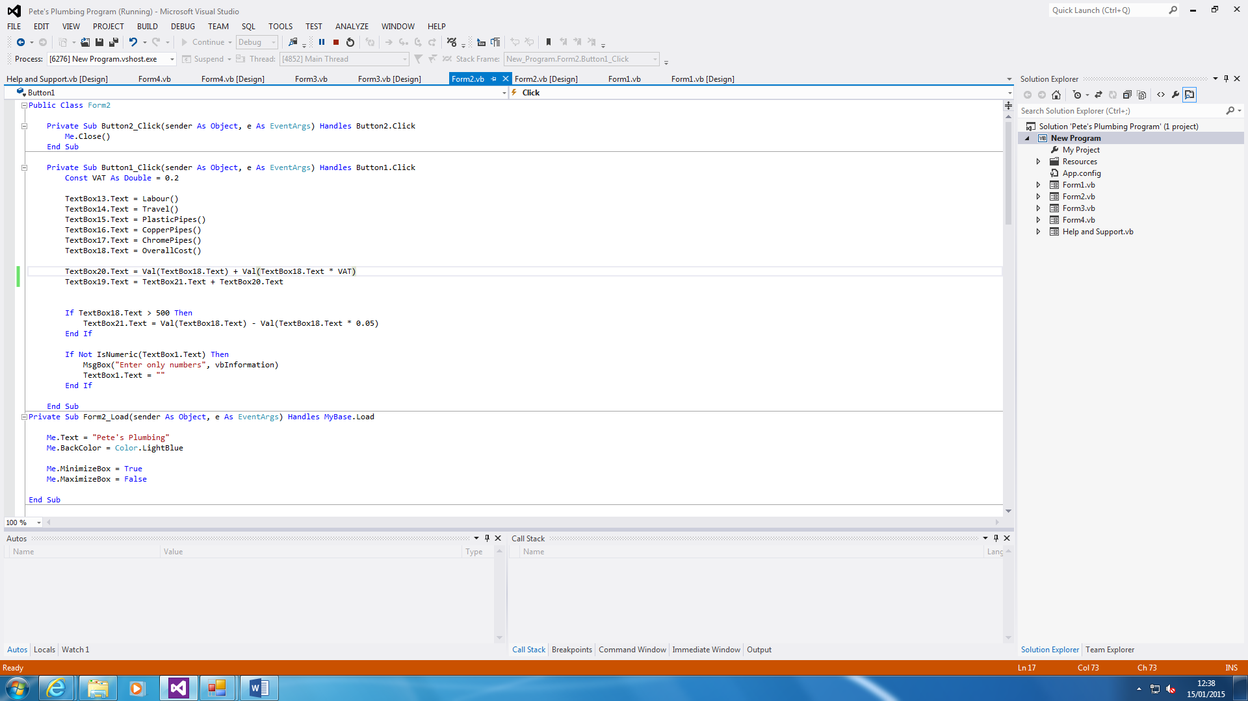

I had to fix this, because when I tested the VAT, it was not working. I put the new code in and it worked. I tested it on the screenshot🡨.